1. **Create an algorithm and a flowchart that will accept/read two numbers and then display the bigger number.**

**Algorithm:**

Step 1: Start

Step 2: Enter two numbers

Step 3: If (n1 > n2) display n1.

Step 4: Else display “n2”

Step 5: Stop

**Flowchart:**

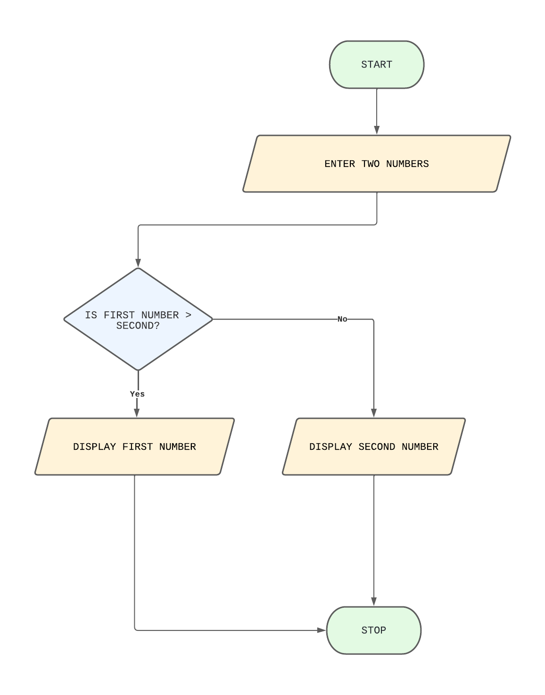

**Java Code:**

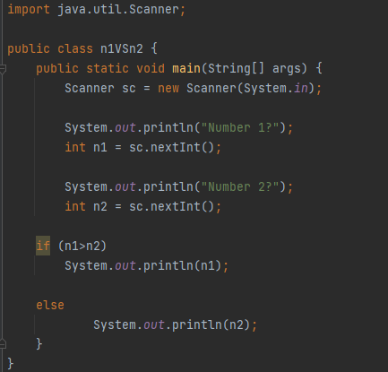

**Output:**

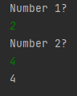

1. **Create an algorithm and a flowchart that will compute the area of a circle.**

**ALGORITHM:**

Step 1: Start

Step 2: Enter the radius(r) of the circle

Step 3: Area of the circle is PI * radius * radius (area = PI * r * r)

Step 4: Display the area of the circle

Step 5: Stop

**FLOWCHART:**

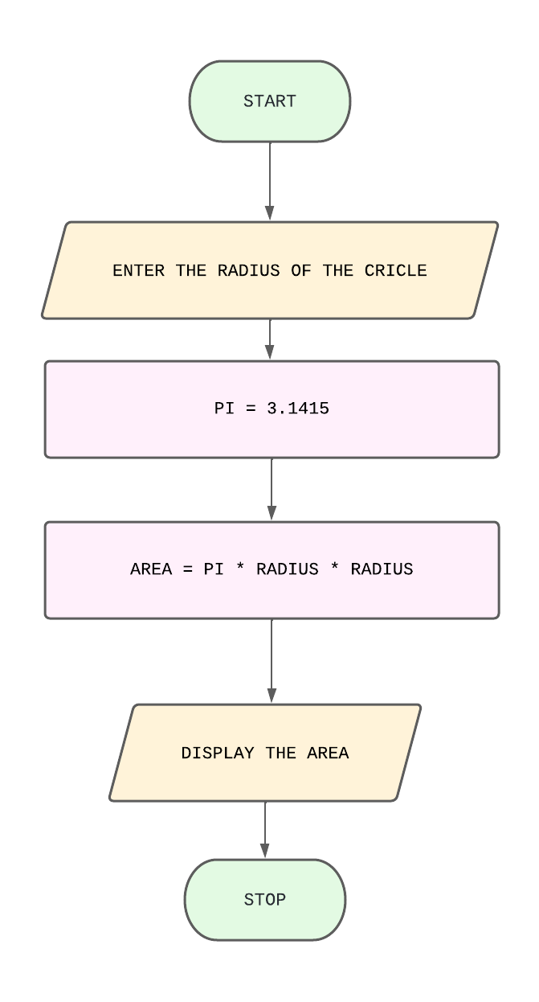

**JAVA CODE:**

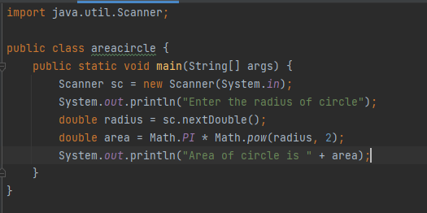

**OUTPUT:**

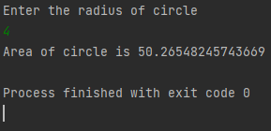

1. **Create an algorithm and a flowchart that will compute the sum of two numbers. If the sum is below or equal to twenty, two numbers will be entered again. If the sum is above 20, it will display the sum.**

**ALGORITHM:**

Step 1: Start

Step 2: Enter two numbers

Step 3: Set Sum to num1 + num2

Step 4: If (sum <= 20); Go to Step 2

Step 5: Else display the sum

Step 6: Stop

**FLOWCHART:**

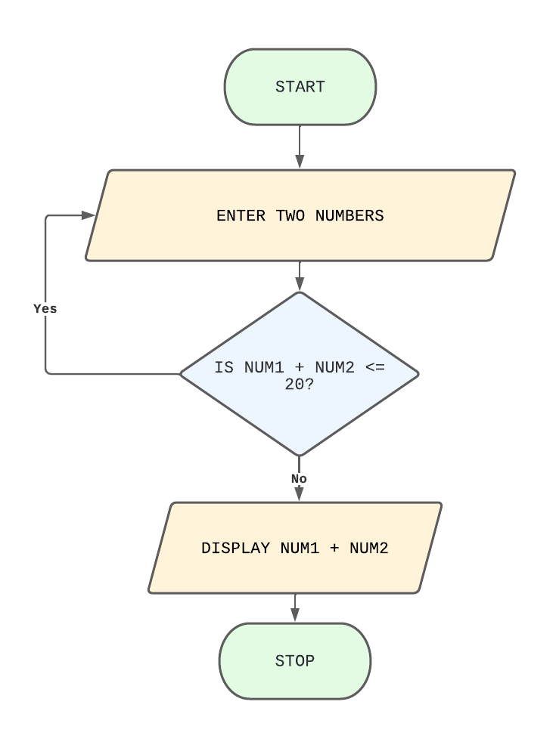

**JAVA CODE:**

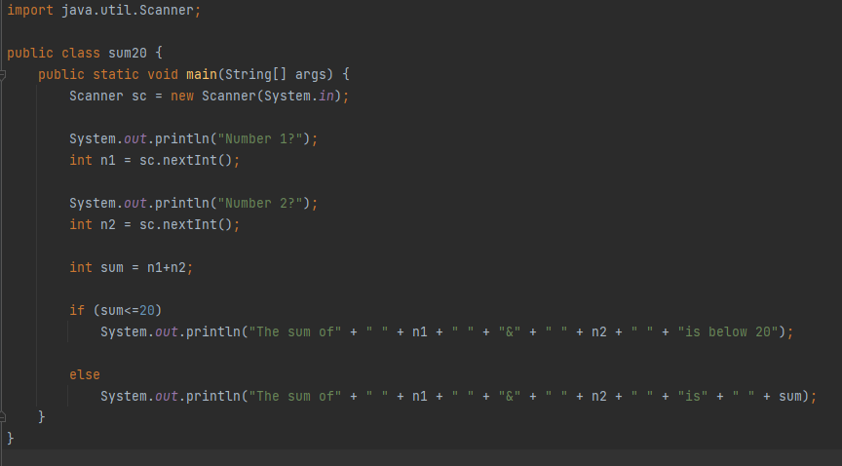

**OUTPUT:**

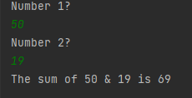

1. **Create an algorithm and a flowchart that will output the largest number among the three numbers.**

**ALGORITHM:**

Step 1: Start

Step 2: Enter three numbers

Step 3: if (num1 >= num2 and num1 >= num3) display num1

Step 4: if (num2 >= num1 and num2 >= num3) display num2

Step 5: else display num3

Step 6: Stop

**FLOWCHART:**

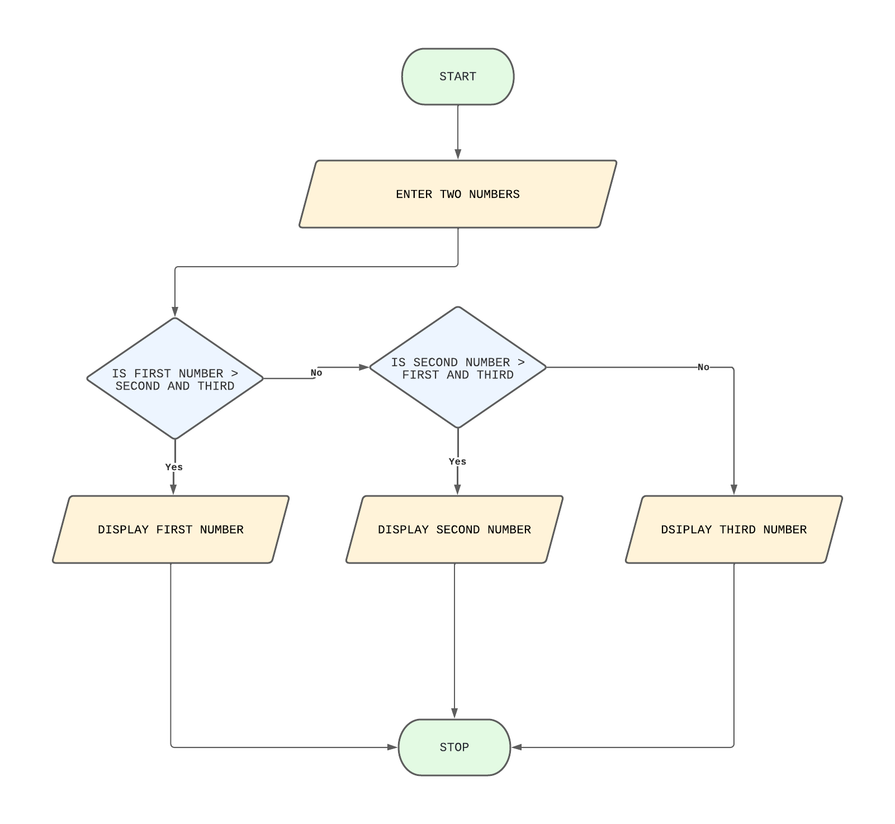

**JAVA CODE:**

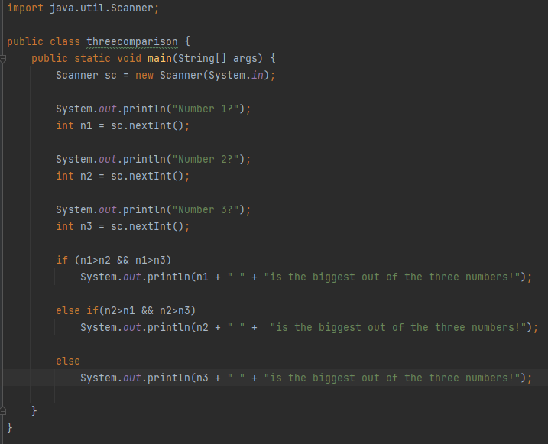

**OUTPUT:**

